LAB EXPERIMENT RECORD

SET 21: ENERGY CONSUMPTION ANALYSIS

Department | AIDS
Course Code / Course Name | DSA0601 / Data Handling and Visualization
Experiment | Data Visualization using R
Name | M V Raghavan
Register Number | 192424373
Date | 13 OCTOBER 2026
Day | Tuesday

Aim
To analyze energy consumption data using a histogram, density plot, bubble scatter plot, and bar chart, and to build an interactive dashboard using R and Shiny.

Dataset: Monthly Sales

Sector | Region | Month | Temperature (°C) | Units Consumed (kWh) | Cost (₹) | Renewable Usage (%)
Residential | North | Jan | 15 | 320 | 2100 | 22
Commercial | South | Jan | 24 | 540 | 3600 | 18
Industrial | West | Feb | 20 | 880 | 5900 | 12
Residential | East | Feb | 18 | 350 | 2300 | 25
Commercial | North | Mar | 28 | 610 | 4100 | 20

PROGRAM 1: Histogram and Density Plot of Energy Consumption
To visualize the distribution of units consumed using a histogram and density plot.
# # Import Dataset
energy <- read.csv("Energy_Consumption_Data.csv") units <- energy$Units_Consumed
# Histogram hist(
units,
probability = TRUE,
main = "Distribution of Energy Consumption", xlab = "Units Consumed (kWh)",
ylab = "Density", col = "lightblue"
)

# Density Plot lines(
density(units), col = "red", lwd = 2
)
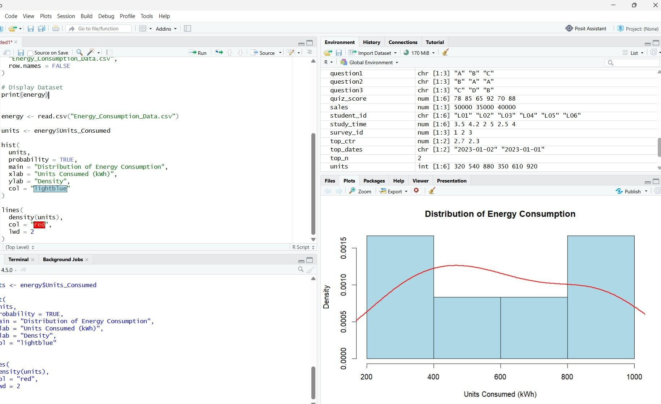
Observation: Energy consumption ranges from 320 to 920 kWh. The histogram displays the frequency distribution, while the red density curve shows the overall pattern of consumption.

PROGRAM 2: Bubble Scatter Plot of Temperature vs Energy Consumption
To analyze the relationship between temperature and units consumed, using bubble size to represent peak hours and transparency to improve visualization
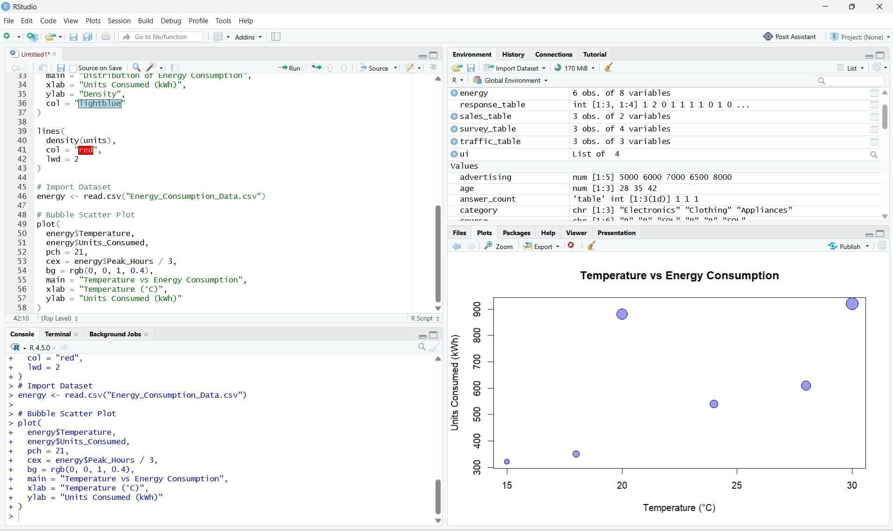
# Import Dataset
energy <- read.csv("Energy_Consumption_Data.csv") # Bubble Scatter Plot
plot(
energy$Temperature, energy$Units_Consumed, pch = 21,
cex = energy$Peak_Hours / 3, bg = rgb(0, 0, 1, 0.4),
main = "Temperature vs Energy Consumption", xlab = "Temperature (°C)",
ylab = "Units Consumed (kWh)"
)

Observation: Industrial observations have the highest energy consumption and larger bubbles because they have more peak hours. The six records alone are insufficient to establish a strong general relationship between temperature and energy consumption.

PROGRAM 3: Average Renewable Usage by Sector
To calculate the average renewable energy usage for each sector and visualize it using a bar chart.
# Import Dataset
energy <- read.csv("Energy_Consumption_Data.csv") # Calculate Average Renewable Usage
average_usage <- aggregate( Renewable_Usage ~ Sector, data = energy,
FUN = mean
)
print(average_usage) # Bar Chart barplot(
average_usage$Renewable_Usage, names.arg = average_usage$Sector,
main = "Average Renewable Usage by Sector", xlab = "Sector",
ylab = "Renewable Usage (%)",
col = c("lightblue", "lightgreen", "orange")
)

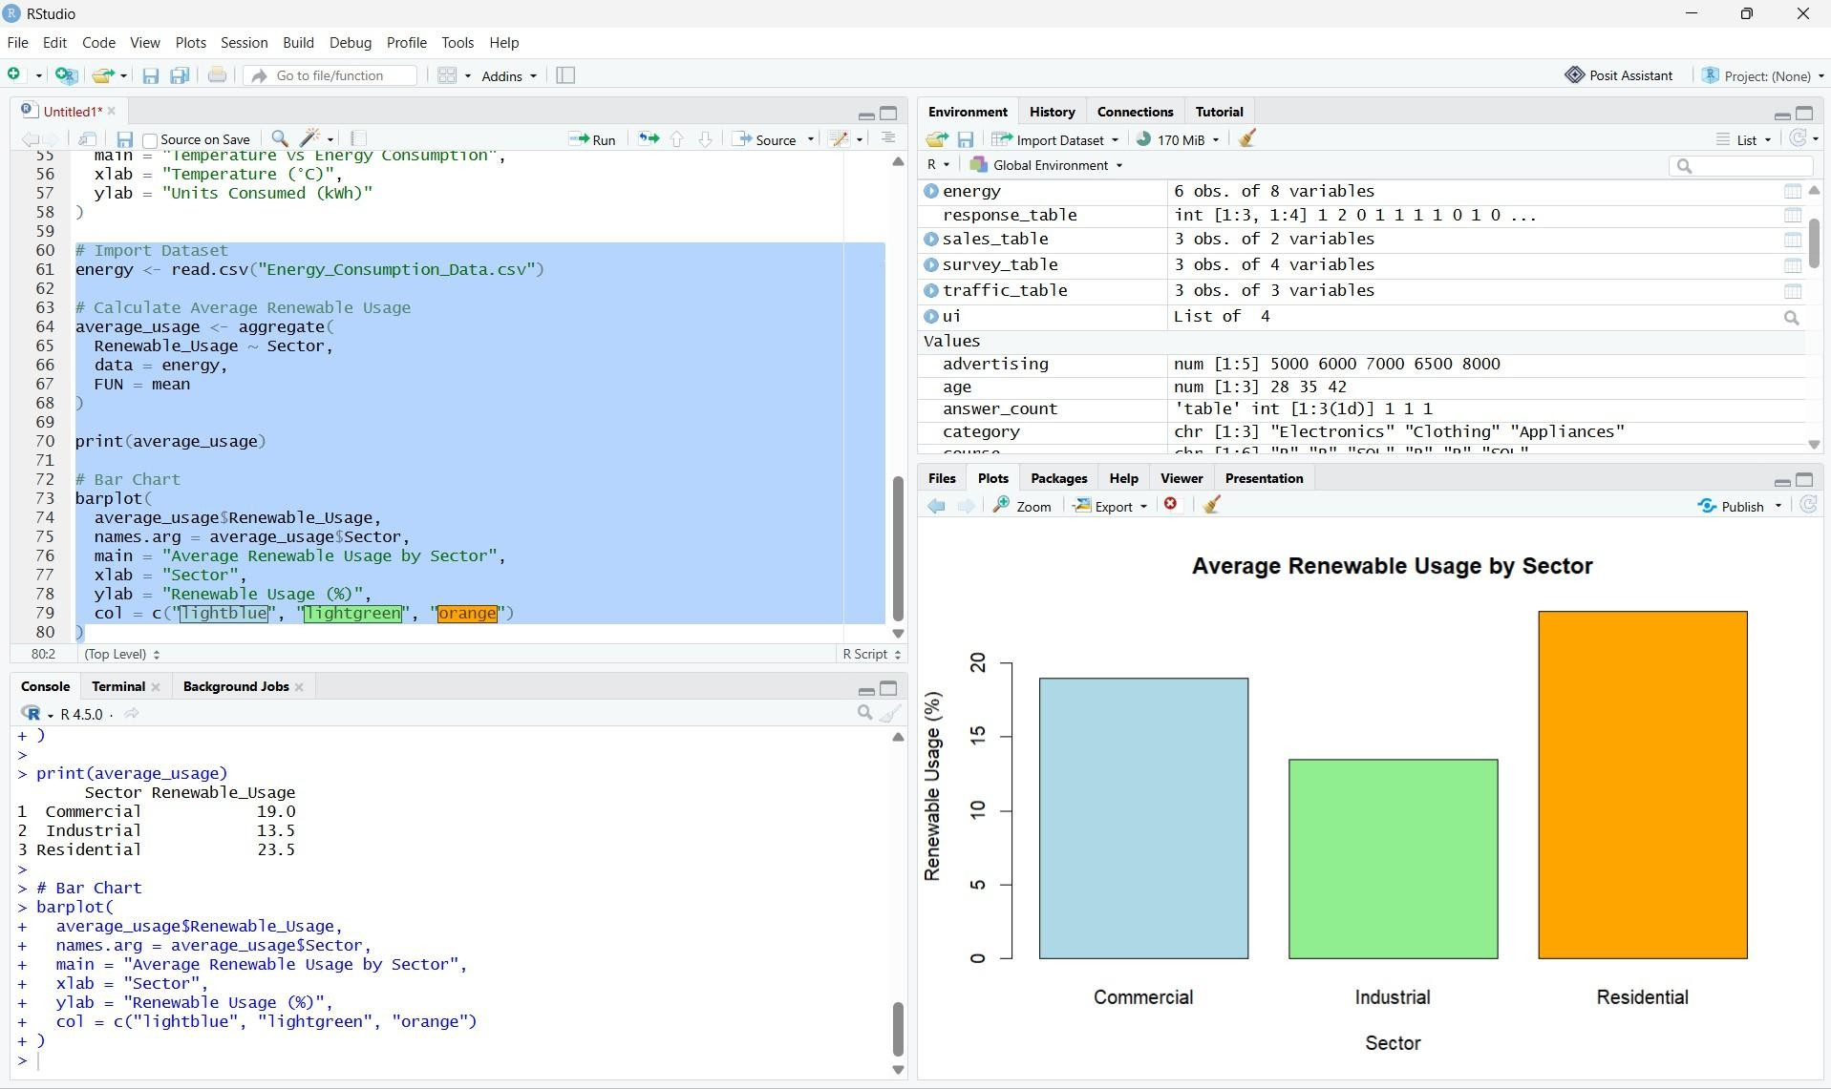
Insight: Residential has the highest average renewable usage at 23.5%, while Industrial has the lowest at 13.5%. This indicates greater renewable energy adoption in the residential records provided.

PROGRAM 4: Interactive Energy Consumption Dashboard
To build an interactive dashboard combining a monthly energy usage line chart, a sector-region heatmap, and a data table using R and Shiny
library(shiny)
energy <- read.csv("Energy_Consumption_Data.csv") ui <- fluidPage(
titlePanel("Energy Consumption Dashboard"), mainPanel(
tabsetPanel(
tabPanel("Monthly Trend", plotOutput("trend")), tabPanel("Heatmap", plotOutput("heatmap")), tabPanel("Energy Table", tableOutput("table"))
)
)
)

server <- function(input, output) { filtered_data <- reactive({
d <- energY

axis(2, at = 1:nrow(heat), labels = rownames(heat))
})
output$table <- renderTable({ filtered_data()
})
}
shinyApp(ui = ui, server = server)

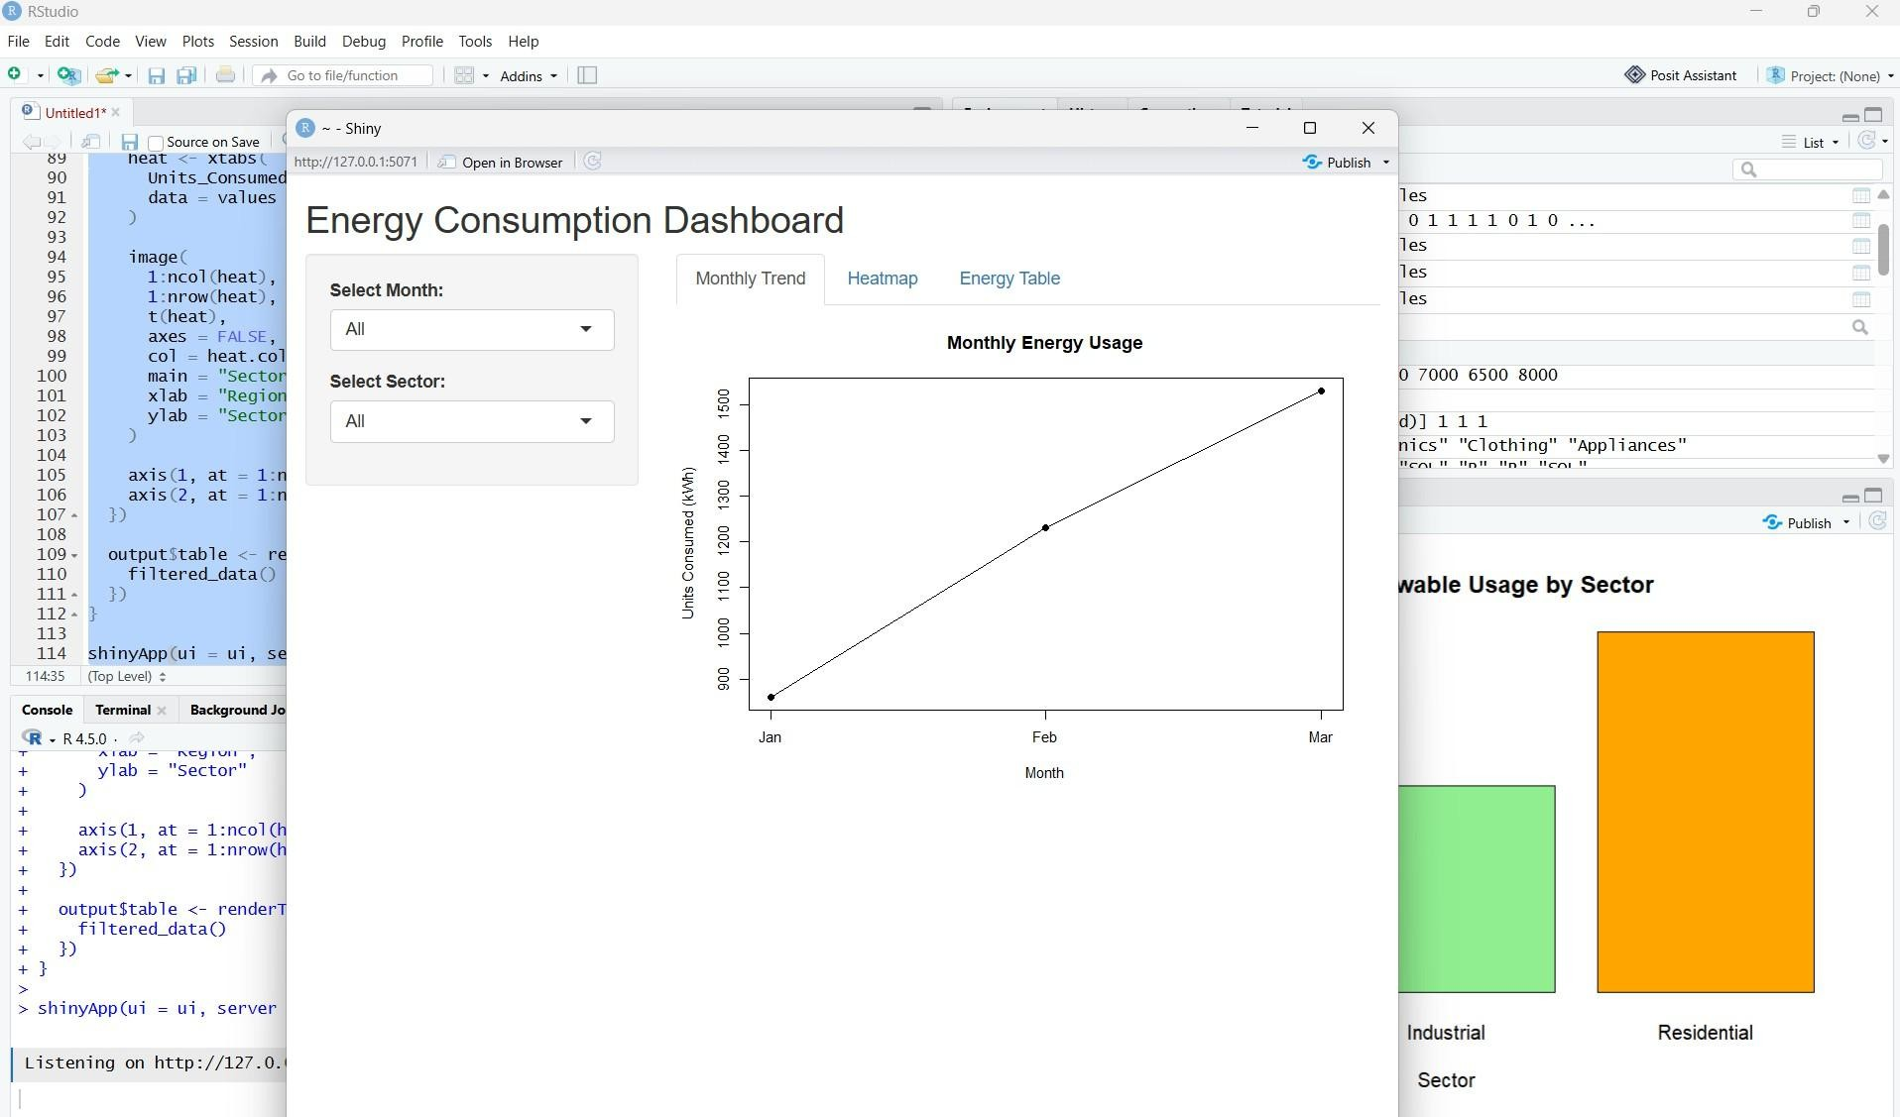
Observation: The dashboard allows users to filter energy data by month and sector, view monthly consumption trends, and compare consumption across sectors and regions.

Procedure
- Import the Energy_Consumption_Data.csv dataset into RStudio.
- Extract the Units_Consumed column and create a histogram with a density curve.
- Use plot() to create a bubble scatter plot between temperature and units consumed, representing peak hours using bubble size.
- Calculate average renewable usage for each sector using aggregate() and display the results in a bar chart.
- Load the Shiny package and develop an interactive dashboard with month and sector filters, a line chart, heatmap, and table.
- Run the dashboard using Run App and explore the visualizations.
.

Result
The energy consumption dataset was successfully analyzed using a histogram, density plot, bubble scatter plot, and bar chart. An interactive Shiny dashboard was also developed to explore monthly energy consumption and renewable energy usage.

